Team Number:
Time:
Rank:


ADMINISTRATIVE
SUPPORT TEAM
(255)

STATE – 2021

Production:

Job 1: Memo (100 points)
Job 2: Itinerary (100 points)
Job 3: Database Address List (100 points)
Job 4: Registration Form (100 points)
TOTAL POINTS (400 points)

Test Time: 90 minutes

GENERAL INSTRUCTIONS

- Check that this test booklet contains Jobs 1-4.

- Correct all errors. Copy is graded on production standards.

- In places you normally use your reference initials, use your team’s number. Your name or initials should not appear on any work your team submits. Key your team’s number and job number in the footer in the lower right corner of all work submitted unless specified otherwise.

- If you finish before the end of the testing time, notify the proctor. Time may be a factor in determining a winner when there is a tie score.

- When turning in your contest, the jobs should be arranged in numeric order. Use your time wisely. You have ninety (90) minutes to complete this test.

- Save all work with your team number on the flash drive provided by the contest administrator.

Production Standards (when specified)
0 errors 100% of assigned point value of each document
1 error 90% of assigned point value of each document
2 errors 70% of assigned point value of each document
3 errors 50% of assigned point value of each document
4 or more errors 0% of assigned point value of each document

TEAM INSTRUCTIONS
You are part of the Administrative Support Team for Digital Solutions, 700 Morse Road, Suite 201, Columbus, OH 43214. Your team has been given the task of creating documents for use at the office. Be sure to use the Style & Reference Manual as a guide in preparing the documents.

Job 1: Memorandum (100 points)

Nancy Wells has asked you to format, according to the Style & Reference Manual, a memorandum to be sent out to all of the department heads (Julie Smith, Harvey Rosen, Tom Carlson, Roger Meyer, and Edna Renick) regarding a new flexible work schedule where employees in their department may flex their time between the office and at home. Please include the following in the body of the memorandum.

We will be implementing for the FY2021 a new flexible working schedule. This schedule will allow the employees in your department to flex their time at the office and at home. The new flexible schedule will be determined by the following qualifications at the discretion and approval of each department head:

  - On time to work
  - 2 consecutive positive evaluations of job performance
  - No letter of reprimand in employee folder
  - High-quality Internet connection
  - Not to exceed more than 5 days out of the office each week

This new flexible schedule will be in place July 1. Make sure to meet with each employee in your department to develop a plan for the schedule when they work at home and the days they will work in the office.

Job 2: Itinerary (100 points)

Nancy Wells would like you to create an itinerary for her following trip to Palm Springs for the Digital Solution Board of Directors Retreat on July 2- 4, 2021. Here is the information for her itinerary.

Friday 7/2 Depart John Glenn Columbus International Airport (CMH) Southwest Airlines Flight 727 (non-stop) at 2:25 p.m. Arrive in Palm Springs International Airport (PSP) at 5:05 p.m. Will need an Uber XL to the Palm Springs Golf Resort. 6:00 p.m. dinner reception with the Board of Directors in the Arnold Palmer Suite.

Saturday 7/3 8 a.m. Breakfast meeting with James Woods, Board Chair, in Arnold Palmer Suite
9 a.m. BoardSource training with Board of Directors, 2nd floor Tiger Woods Suite,
Noon- Luncheon with Google Executives
2:00 p.m. Digital Solutions Board of Directors 2022 Strategic Planning
5:00 p.m. 18-hole round of golf on Palm Springs Golf Course
7:00 p.m. BBQ Dinner Palm Springs Golf Clubhouse

Sunday 7/4 7 a.m. Uber XL to Palm Springs International Airport (PSP)
9:30 a.m. Leave Palm Springs International Airport (PSP) on Southwest Airlines Flight 869 (non-stop)
Arrive at John Glenn Columbus International Airport (CMH) at 1:10 p.m.

Job 3: Database Address List (100 points)

You will create a database of sponsors who will be attending the Sponsor Reception at the Tech Expo in Orlando. You will create a table named “Sponsors”.
Create the field names shown below, and type the information shown below into the table. Sort by last name. Print table in Landscape.
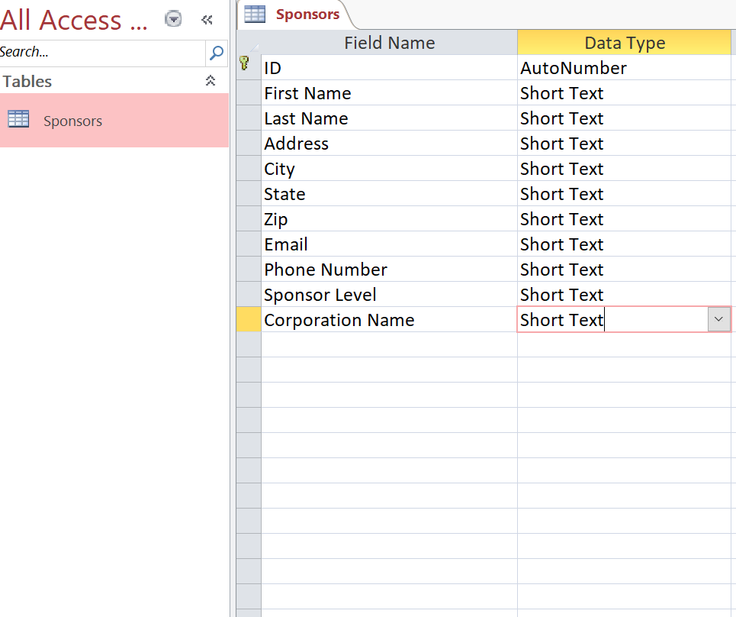

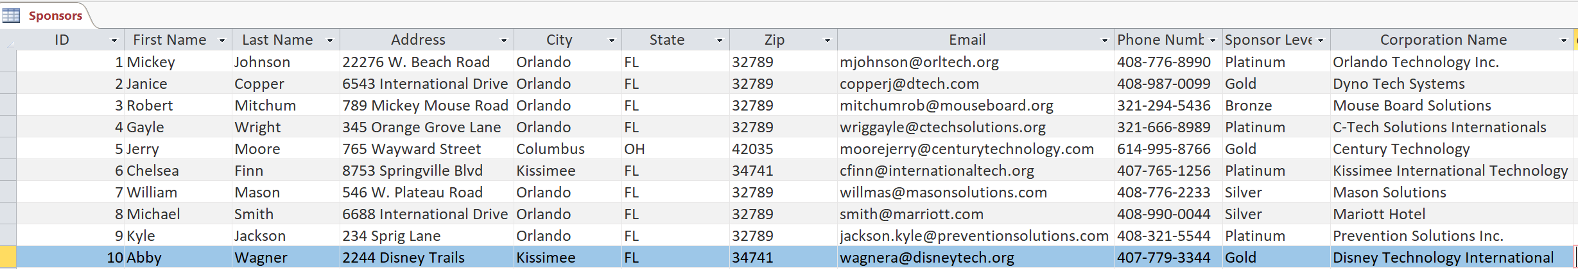

Job 4: Registration Form (100 points)
Nancy Wells would like you to create a registration form for vendors for the Tech Expo in Orlando. Include the following information on the registration form.
Include an outside border, line width 2 ¼ pt.
Title (centered) Digital Solutions Vendor Registration
First Name
Last Name
Address
City, State & Zip
Email Address
Company Name
Company Website
Vendor Booth- Full Size Booth $10000 Medium Size Booth $5000 Small Size Booth $3000
Payment type- Cash Check Credit Card
Technology Needed at booth Yes or No, (circle one) If Yes what is needed
Submit form to erenick@digitalsolutions.org

